**What Is 0x Protocol?**

A Step-by-Step Guide to a Key Peer-to-Peer Software Network

By: [**Rahul Nambiampurath**](https://thedefiant.io/author/rahul-nambiampurath)    October 26, 2022

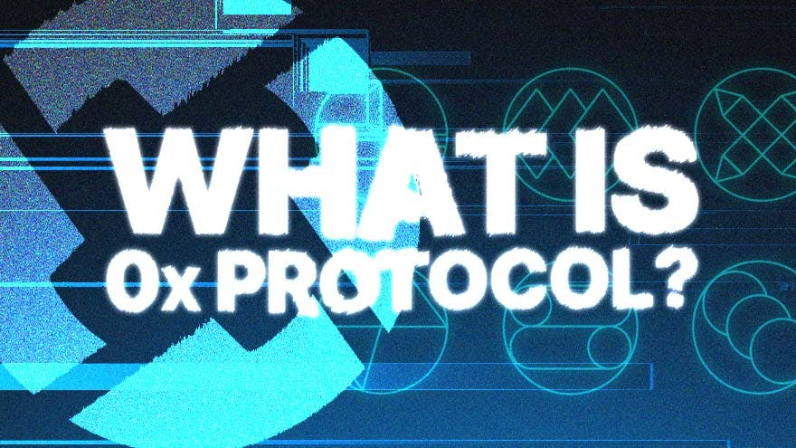

Ethereum is positioning itself as the open-source infrastructure for digital assets.

Smart contracts that automate loans, NFT trading, play-to-earn games, exchanges are just some of the offerings designed to transform traditional finance into decentralized finance (DeFi).

0x, a peer-to-peer software framework, is built on top of Ethereum’s infrastructure. 0x, an open source protocol, uses Ethereum to tokenize real-world assets and eliminate intermediaries.

**Mirrored Assets**

Virtually any asset is tokenizable. 0x makes traditional assets available on Ethereum blockchain. Whether they are company shares, bonds, or real estate, 0x can mirror them on Ethereum as tokens.

Specifically, 0x creates decentralized exchanges on which these mirrored assets are traded. With 0x Launch Kit, developers can build their own DEXs and customize them.

In other words, 0x is the Lego of the DeFi world, providing components to build crypto markets:

* Over-the-counter (OTC) trading desks
* Etsy-like marketplaces for digital assets
* Arbitrage trading bots
* Decentralized exchanges for swapping digital assets

0x supports all of its smart contract standards, from ERC-20 for regular tokens to ERC-721 and ERC-1155 for non-fungible tokens (NFTs).

One of 0x’s big advantages is its API (Application Programming Interface), which developers may use to link 0x with their own existing dApps.

For example, 0x can deepen the liquidity pool of lending and DEX dApps by aggregating liquidity from both on-chain and off-chain networks.

In addition to Ethereum, 0x has expanded its API liquidity aggregator, called Matcha, to Avalanche (AVAX), Fantom (FTM), Celo (CELO), Binance Smart Chain (BSC), Polygon (MATIC), and Optimism.

**0x Origin**

In 2016, Will Warren and Amir Bandeali founded ZeroEx to develop the 0x protocol. Warren has a B.S. degree in mechanical engineering from UC San Diego.

Prior to committing to 0x, Warren was a technical advisor to Basic Attention Token (BAT), and won the Consensus 2017 Proof of Work Pitch Competition.

Amir Bandeali has a degree in finance from the University of Illinois at Urbana-Champaign, and served as ZeroEx co-CEO and CTO. He previously worked at Chopper Trading. In July 2017, the two co-founders arranged an ICO for 0X and raised $24M by selling ZRX tokens.

In total, 0x has raised $109M across 9 funding rounds, led by Polychain Capital, Pantera Capital, Blockchain Capital, to name a few. Coinbase co-founder Fred Ehrsam serves 0x in an advisory role.

**How Do DEXs Work?**

0x protocol has a dual role: tokenize off-chain assets and facilitate the trade of those tokenized assets.

To get a firmer grasp on how 0x protocol works, its useful to understand how decentralized exchanges work.

In contrast to centralized exchanges such as NYSE or Binance, DEXs do not have centrally owned market makers to provide liquidity. These market makers make trading fast and efficient because they cover for ask/bid spreads on either side of the trading equation.

DEXs, powered by smart contracts rely on users to provide liquidity. For example, Uniswap DEX consists of smart contracts that pools tokens from liquidity providers. Traders looking to swap tokens then tap into those liquidity pools, giving liquidity providers a small cut.

DEX liquidity relies on the number of liquidity providers and their focus on specific token pair pools, such as ETH/USDC, for which they provide liquidity. This can become problematic when looking to exchange less common tokens, or when there is high demand.

**How Does 0x Work?**

0x protocol uses a hybrid off-chain/on-chain settlement protocol. While typical DEXs operate exclusively on-chain, 0x can tap into liquidity beyond on-chain networks. That’s because 0x stores trading orders off-chain, executes trade settlements on-chain.

Under this hybrid system, 0x gas fees are cost-efficient. This process is conducted with two 0x protocol actors:

* **Makers**: they provide liquidity by creating 0x orders in the order book. When makers place orders, they detail the tokens involved and their exchange price. Then, they wait for the price to be matched.
* **Takers**: they siphon liquidity from the order book by placing orders that are matched without delay.

If a maker is already familiar with a specific taker, they can send the order directly to them via over-the-counter (OTC) trading desks or general messaging apps. But in most cases, makers do not know takers.

This is when the order is first submitted to 0x relayer, via 0x Mesh, which is a peer-to-peer (P2P) network for sharing orders in the 0x messaging format. In turn, the 0x relayer is Matcha, which facilitates the creation and matching of orders.

Instead of having centralized middlemen, 0x relayer maintains the off-chain order book, including transaction fee collection. Once the order is relayed to a blockchain, 0x settlement protocol verifies the maker’s signature and executes the token swap. It is important to note that relayers do not hold tokens in custody at any point.

**ZRX Tokenomics**

As with all native protocol tokens, ZRX is both a utility and governance token for 0x. ZRX token holders can use their stash to vote on 0x Improvement Proposals (ZEIPs), just like ETH token holders do the same for Ethereum Improvement Proposals (EIPs).

In the case of 0x, this ZRX voting weight extends to even off-chain proposals, due to its hybrid nature.

**Voting Weight**

Each ZRX token counts as one vote, so the voting weight is proportional.

Market makers can stake their ZRX token to receive rewards for providing liquidity on every 0x trade. These fees are ETH-denominated and automatically pooled into smart contracts for staking. While ZRX tokens are locked into a fixed time period, called epoch, makers collect them from the staking pool after each epoch ends.

As for 0x staking rewards, they are in flux, dependent on the trading volume and set protocol fees. Both staking and voting is handled on [0x website](https://www.0x.org/zrx/vote). ZRX token holders can also deposit their funds into 0x DAO treasury.

Not only are these funds used to forge partnerships to bolster the 0x ecosystem, but ZRX token holders themselves can submit funding grants.